CMPUT 302
Human Computer Interaction
Project Design
Interactive Surface - Target Tapping

By: Adam, Shawn; Boutet, Patrick; Padlesky, Aaron; Santos, Eddie
Motivation And Goals:
First let us set the stage of what the application we have been tasked to develop is. The project itself consists of an application running on a touch-enabled table. The application will be capable of displaying objects (shapes, numbers, and letters) of which a disabled person can attempt to touch. The purpose of this is to allow patients to regain mobility and coordination in their gross and fine motor skills. Our application will provide what we refer to as a level editor, this allows therapists to layout the objects and specify their size, color, shape, and position. These layouts, referred to as levels, can be saved and loaded for use in future therapy sessions with patients. It is our opinion this design for the application is a well formulated model, and can be quite beneficial for all future users.
The motivation for this project can be summed up in five main points. First and most important is that the software we are developing will be directly assisting in the rehabilitation of peoples gross and fine motor skills. Next it will further extend the usage of custom touch table top hardware that the Glenrose Rehabilitation center has heavily invested in. Third is that it will ideally make the jobs of physical therapists easier and more productive. Fourth is that it will give valuable data on patient’s rehabilitation process that not only contributes to the effectiveness of the physical therapists job. But that the Glenrose Center can use to further evaluate the ways in which they try to rehabilitate people. Which could possibly contribute to policy and budget decisions in the future. Last is that it provides a very valuable learning experience for us as computing science student in exposing us to touch based input hardware, code frameworks that support such hardware and evaluation methods on UI effectiveness.
As of now, our project is at the halfway point, and the motivations remain the same for the project. But some of our goals for the project have matured as we have become more experienced in the XNA framework we are using to design our application. One goal in particular that has progressed is that those of us working on the frontend creating the GUI have gained invaluable experience at designing a user interface to be used with touch hardware, as well as designing GUI elements capable of handling mouse and touch input. This has pushed us to do more with what we have learned in developing UI elements in the XNA framework.
We will now continue discussing our goals for this project. Below are the main goals that we have for our halfway point of this project. Design a highly usable and easy to learn table top touch based interface for our application. Be able to meet all the core client requirements that they have requested. Implement as many of the nice-to-haves that the client has also mentioned.
Some specifics what we are hoping to achieve is to provide a high-quality interface that is simple and intuitive. Making the application focus on simplicity and quality over having a larger feature set. Simplicity is evident throughout all our working prototypes so far. With this as one of the leading design goal we feel the client will be presented with an application that cannot fail to meet their needs, and that future users will be able to quickly learn and implement in their busy work process. The potential this application has to aid future patients in rehabilitation is high, and we are pleased to be the ones developing this tool.
To continue with the specific underlying goals we have used sub-goals to help us hopefully achieve our main end goals. Intuitiveness is our first sub-goal. “Intuitiveness” means that the therapist using our application can look at the interface and immediately know how to work the application; currently we feel this is the case. We want to minimize the use of complicated menus and feel this has already been achieved. We want the user interface to guide the therapist in how to set up the right game for the patient. For the patient then, we want their interface to be simple and solid. We realize that the patients will have a variety of health conditions ranging from coordination problems to having very limited mobility and/or cognitive ability; therefore we seek to eliminate the possibility that the patient may perform accidental actions within the system. This sub-goal has yet to be achieved, but we have a well-formulated plan to achieve this goal. Our next sub-goal is to create an appealing GUI for the client and patient. We understand exorbitant amounts of detail may overwhelm the patient rather then delight the patient. As such, all of our graphics are very simple, yet appealing and professional looking. Another sub-goal is to favor ease of learning over everything else. This means we want all therapists to master using the game/application. We will not implement un-needed features, and will continually think of how to make every part of the user interface as simple to use as possible, just as we have up until now. One very specific sub goal we set was at no point in our programs execution should there ever be a need for keyboard or mouse and this has also been achieved.

Interaction Design:
The following pages area mockup of our user interface in the context of multiple use cases. Currently, our implemented UI follows these exact layouts. Some minor changes have been made for implementations sake, but on the whole, up until now, we feel we have successfully implemented our UI both theoretically and in practice.

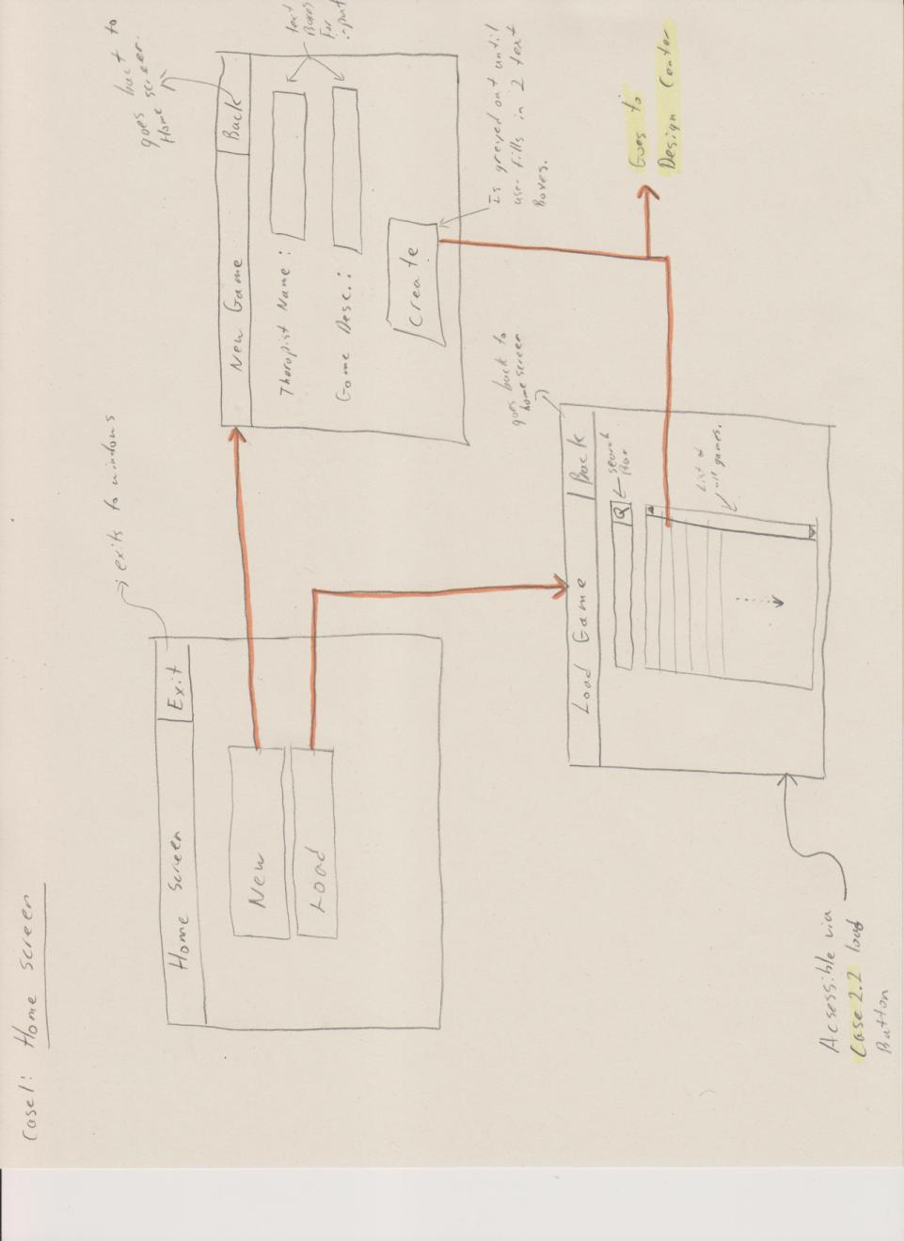
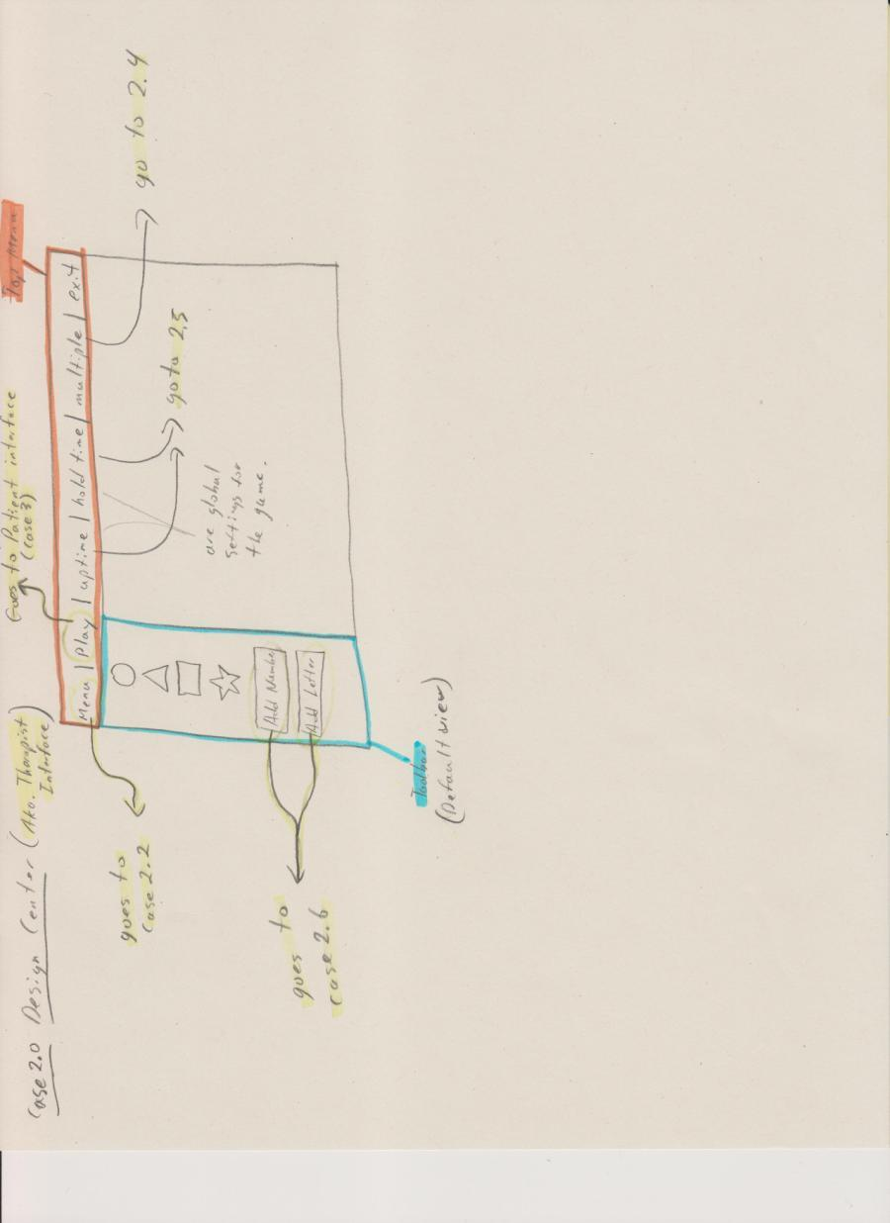

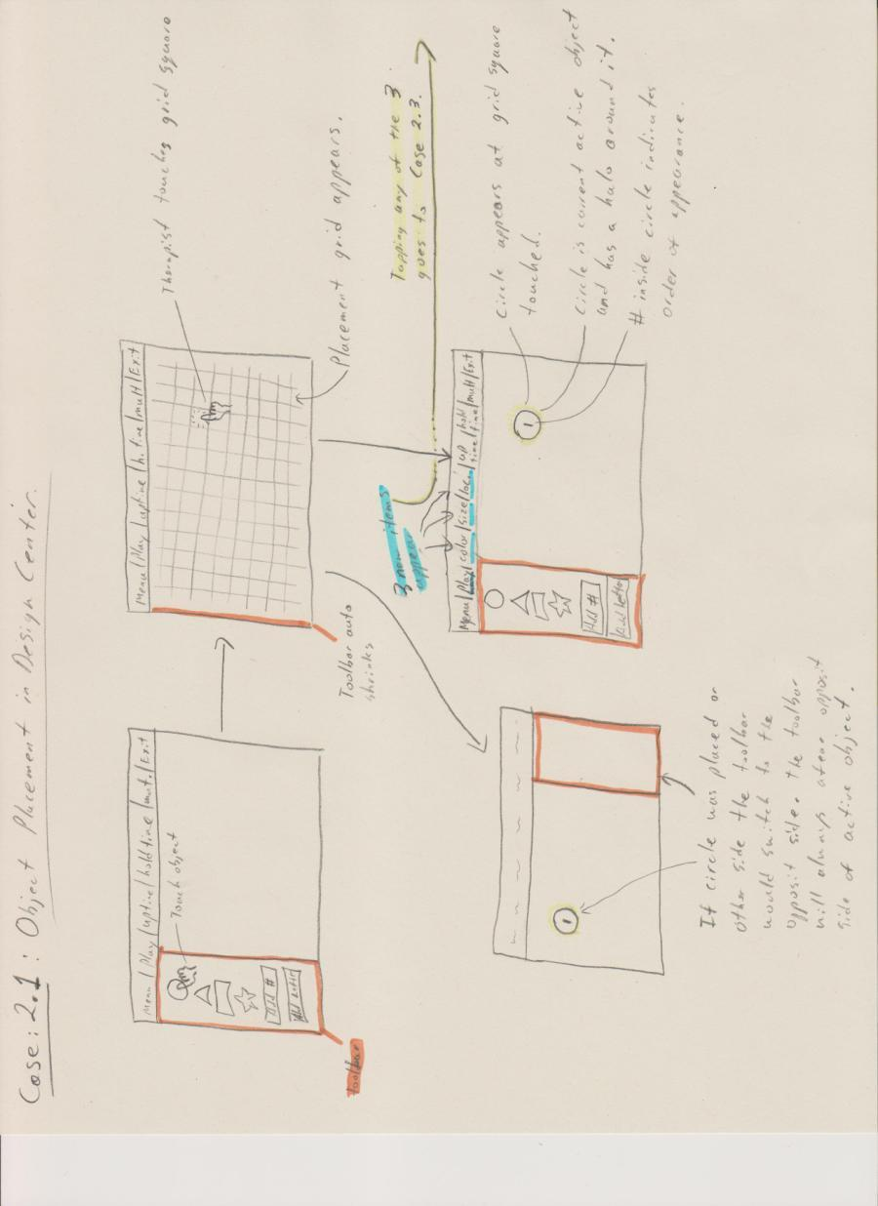

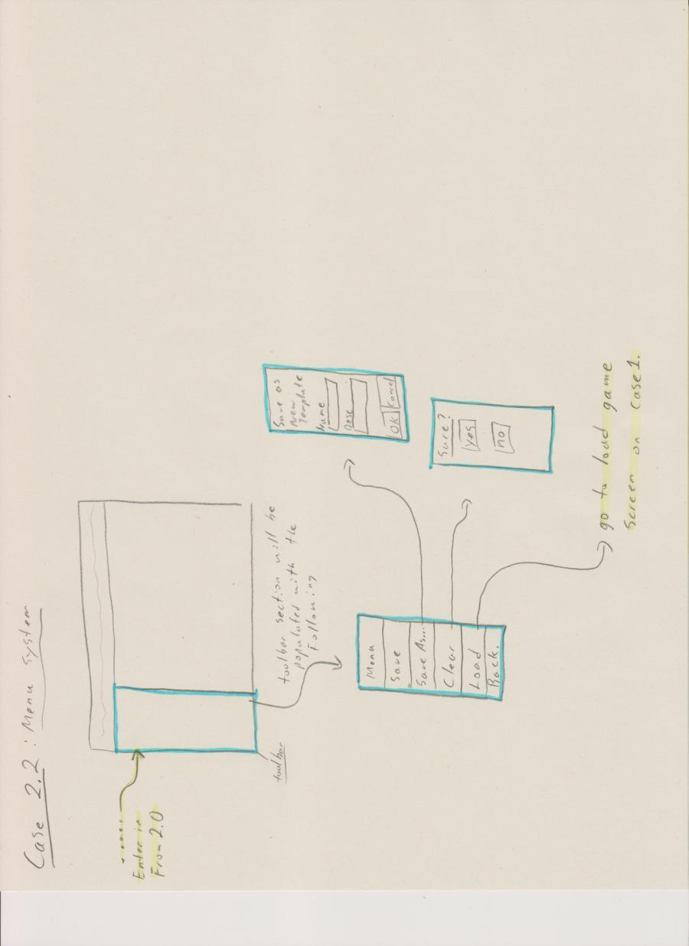

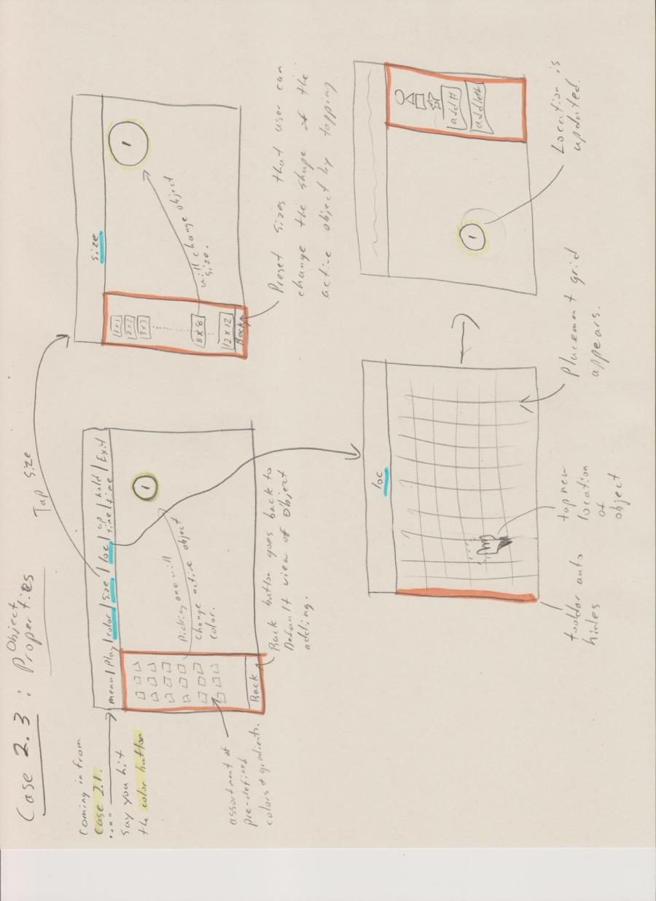

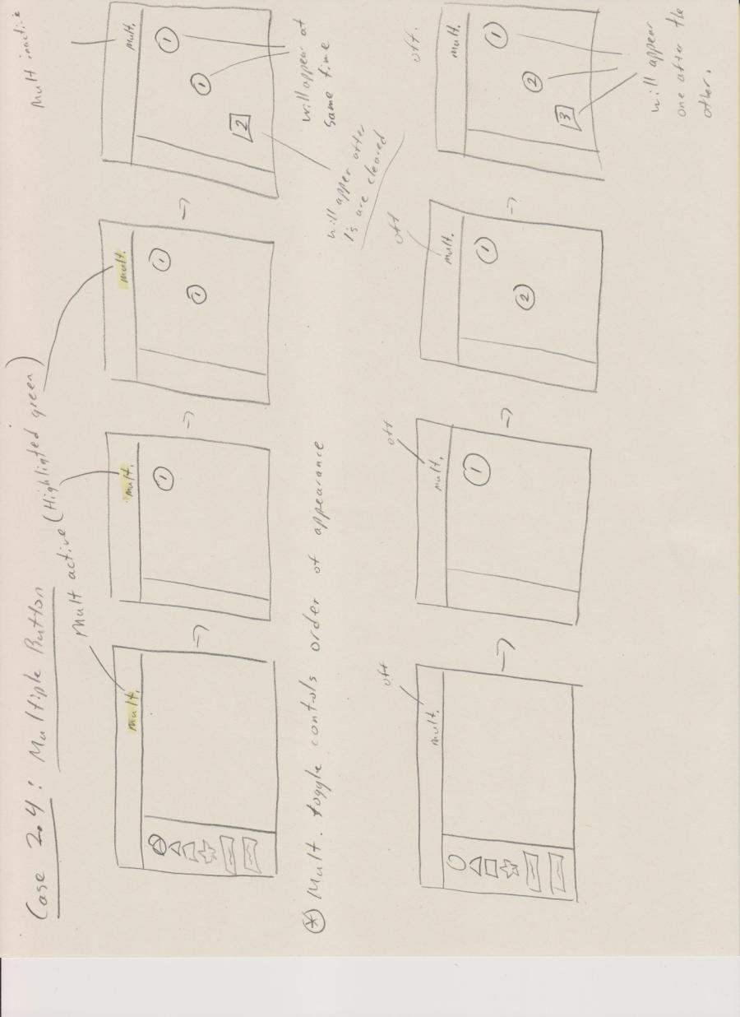

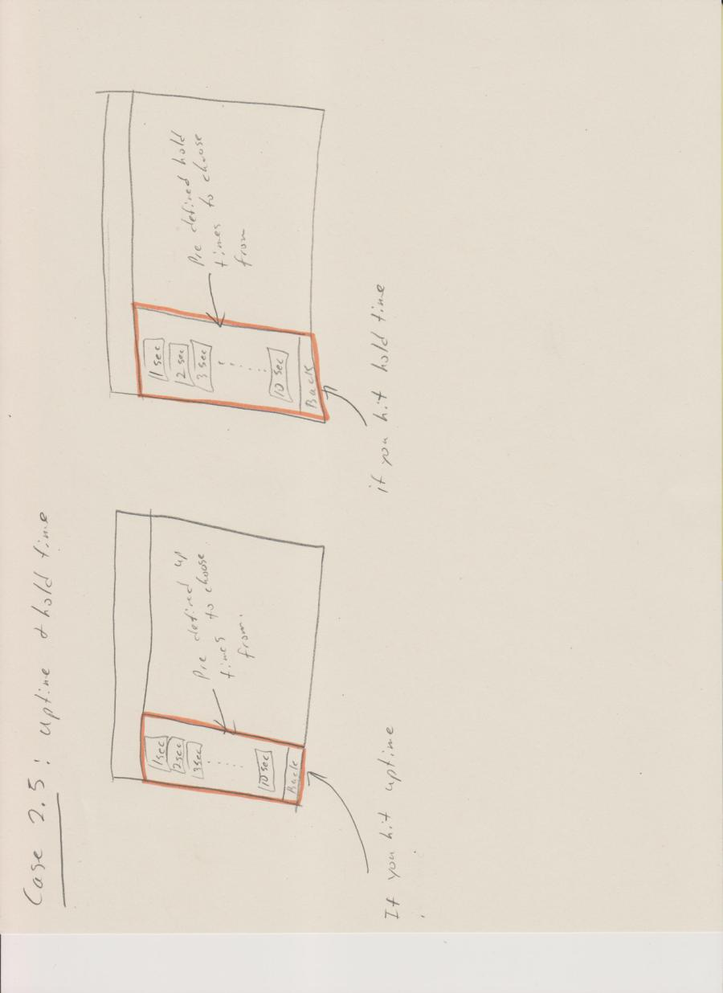

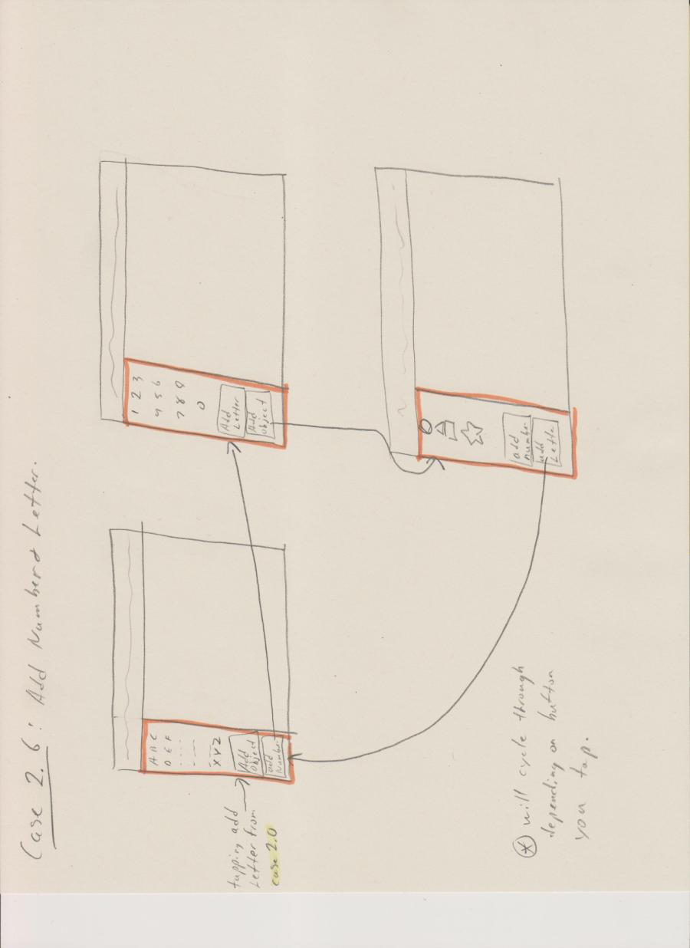

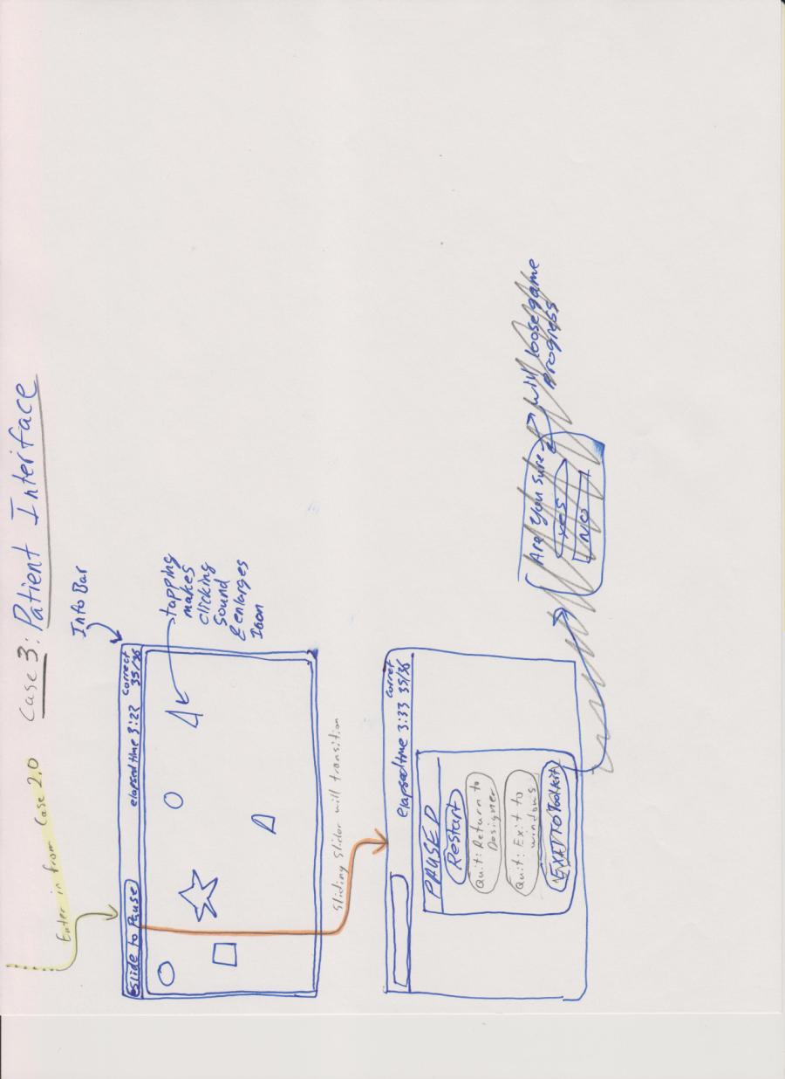

System Design:
The following Figure_1 is a high level summary of our application stack and supporting hardware. Please use it as a quick reference of the design, for a detailed design, please see the write up after figure_1.
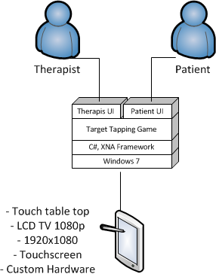
Figure_1
This application deliverable will be required to install on and work alongside the Windows 7 operating system. We have been using C# and the XNA framework to implement the deliverable. Hardware will consist of a PC running windows 7, and a custom designed touch screen tablet. Up until now development has taken place inside the Windows 7 and Windows 8 OS and we have experienced no issues with cross compatibility on the operating systems. The tablet is constructed from a large flat screen LCD TV with 1080P screen resolution, currently our application uses 720p resolution so we could program on our laptops, when the application is nearly ready for delivery, we will optimize for 1080p resolution. The television speakers are connected to the PC, which allows us to implement audio feedback, which is currently on our to-do list. Supporting the television physically is a desk-like custom device that is capable of many adjustments. A custom touch screen is positioned directly on top of the televisions screen. Full touch integration enables the application once it is loaded, to appear self-contained inside the touch device, having no need for peripheral devices. Our goal is to give this custom application the feel of a stand-alone tablet, which many people are now becoming quite familiar with.
The application itself has two main states; these states will be referred to as the patient interface and the therapist interface. The patient interface is very simple and intuitive. Essentially the only interactions available inside the patient interface are to tap/tap&hold the symbols that will be used for patient rehabilitation; and to slide across the menu bar to pause the game. The slide-to-pause currently is implemented as a standard button, but this will be amended. Upon pausing the game from the patient interface a menu appears giving options to the user on how to proceed next. The other side of the application is the therapist interface. The therapist interface allows the user to start the game for the patient. As well, from here the therapist can load previously saved game configurations, and create new game layout configurations. Levels will be saved as stand alone xml files(level meta data and node elements representing all the shapes and their properties) and will be accessible from the in game browser.
The touch interface will soon have feedback added, such as sounds and visual events when objects are touched. The display of the TV will be the intended application to view the interface. Therefore we will optimize the game to be displayed in 1080P (1920x1080) resolution; it currently is optimized for laptops at 720p resolution. In full screen mode currently the resolution makes the interface appear slightly fuzzy, but maintains formatting. To remove complications with peripheral devices we use an on-screen touch keyboard whenever input is required from the user for labeling.

Implementation Details:
Our application is split into a frontend and backend, in the frontend is a screen manager, which controls what is displayed at any given time. Graphical objects such a buttons and labels use Texture2D as their image type, and these are drawn to the screen. A button class allows us to interpret touch/click events and trigger actions from those events.
The backend is designed to draw/move shapes throughout the placement grid, as well as maintain information on what comprises these images, such as color, size, position, and overall shape. These are generated programmatically and do not use static textures reducing overhead/complexity and making these shapes highly flexible. The backend as well contains the ability to save and load previously created layouts.
A large collection of bitmap images has been drawn for display in the application. This includes mainly button graphics and label graphics. Sizes are subject to change once we switch to 1080p resolution and test on a full size TV. Graphics found inside the patient game will be dynamically created by classes written to handle dynamically changing graphical images.
We are currently using libraries all supplied by Microsoft . This includes the XNA 4.0 game framework, .Net framework, and built in libraries for C# to handles strings, math and more. Code has not been taken from any third parties at this time except from http://www.youtube.com/watch?v=54L_w0PiRa8 which explains how to use a menu system. Code was also supplied by Michael Cimolini, a game template which we do not use directly but consult for organization structure and class layout. Second is that Mr. Cimolini also provided a game library dll that contains some very useful code that we have incorporated into our application. Specifically things like his buttons, screen manager, screens, and collision detection. The use of this is critical as it has ensured that our UI elements have been designed for and tested on the custom touch table top hardware.
Lastly in order to help organize our code we have organized these classes into several packages that group similar functionality or closely tied classes together. In general we have a frontend package, a backend package, and a content folder filled with sub-folders of graphical content.

Proposed Empirical Evaluation:
In our project development we plan to have a functioning prototype with all required features completed long before the delivery date of the system. With this functioning prototype one of our objectives it to have it tested, in a very qualitative way, by a therapist that will be a potential user. Our objective is to first understand how well the user can infer the usage and the features of the program. After we evaluate the user’s ability to use the system without help, we will request they rate the systems usability and learnability on a scale from 1 to 10. We then will explain the system and how we intend it to be used, after this we will give them another chance to explore and use the system, and once again get them to make a rating. If we find that the systems usability and learnability is sufficient we will feel quite confident in our design and move on to more quantitative testing. If however they find the usability to be unacceptable without first being explained the system, and once again find it difficult after explanation we will have to seriously re-evaluate the design. However either way we will be asking those users who tested the system what kinds of changes, additions, or subtractions to the system would be helpful to aid in ease of use.
As mentioned above if our qualitative testing is successful we will attempt more rigorous quantitative test methods. We will gather approximately 20 user’s worth of data; these users will be general population as for this test they simply have to be unfamiliar with the interface we designed which would be an identical situation to a therapist using it for the first time. We will write test code into the program that is able to track the time between different actions. We will then explain how to do an action, such as create a new design template, change an objects color, size, or location, etc.. The user will then attempt the action and the code will track their time. Once we have time data on actions from general users we will perform the same tests but with ourselves as experts on the interface. We can then take the average time of the users (beginners) and compare it to our average x 2 (experts) via a t-test. Then see how different the two data sets are and based on if we see a statistical difference or not make two conclusions. First is if there is a difference between the two data sets then we can say that our interface is not as usable as we would like it to be and take the effort to find out what the roadblocks for users are. Second is if there is no difference between the two data sets then we can say that we have built a very usable interface with a low learning curve. Overall we want to be testing how long it takes the users to figure out the user interface instead of how to use it.

Risk Management:
After meeting with our client, and determining many of the requirements for this system we have identified the following risks that could jeopardize the success of our project. The lack of access to the hardware poses a risk. With less time to test on the actual hardware it is possible to miss bugs when we have to rush through testing when the hardware is accessible. We have been assured however that mouse and keyboard testing will be quite accurate and representative of the performance of the real hardware. This risk is lessened by the fact that we are using custom code written by Mr. Cimolini that generates UI elements built to work on his custom hardware. We have also asked our client to test our code on the hardware when he is available, convenient access to our code repo ensures quick and easy access. To lower this risk further, on the days we do have access to the hardware we will plan our tests and be prepared to maximize efficiency. We plan to have a working prototype ready early on, and always strive to meet the important requirements first. This will make sure our code works correctly on the hardware long before the deliverable deadline. If we have a strong basis to work from, we feel we can limit the risk of nearing the deadline and being forced into a rush to accomplish functionality. To monitor all these risk we will constantly re-evaluate and discuss risks, always looking to identify new risks. We will post all risks to the wiki, and monitor their probability and effects.

Project Schedule:
To make sure we meet the deliverable deadline we have thoroughly thought through a schedule we plan to follow as faithfully as possible. We feel at this halfway point we have a solid functioning prototype. This will make sure we have the main requirements completed as well alleviate last minute stress. To limit the possibility of unexpected delays affecting the completion of the project we have set all main requirements to be met as soon as possible. In this way we plan to develop the system in layers. First meeting main requirements, then adding layers of functionality and performance. We have set many milestones and many tasks that will allow us to achieve said milestones. One is to develop custom aesthetic graphics for the application. The front end will consist of 5 main milestones. The menu bar and grid inside the patient interface; and menus, design screen, and home screen inside the therapist interface. These larger milestones will include smaller tasks inside their development. On the backend we have set the ability to create levels, the ability to save levels, the ability to process touch, the menu backend, event handling and object creation all as milestones. Again these milestones will have smaller self-contained tasks that do not cut as widely across the application. Deliverables include project design, ethics, prototype 1, the final product, and all code documentation and design documentation.
The above deliverables, milestones and their affiliated tasks have been laid out in a Gantt chart which specifies specific dates and durations for the project. It has been updated to reflect the current timeline for our schedule from March 15, 2013 onward. Specifically tasks 32 to 48 have been updated. Please see that section of the GANTT for the new upcoming timeline.
Please see attached external GANTT chart for our project schedule and milestones.
The GANTT chart is a very large high resolution image file, too big to embed in this word document. Please see the GANTT_chart_v4.png file attached to this email or get it out of our code repo at:

